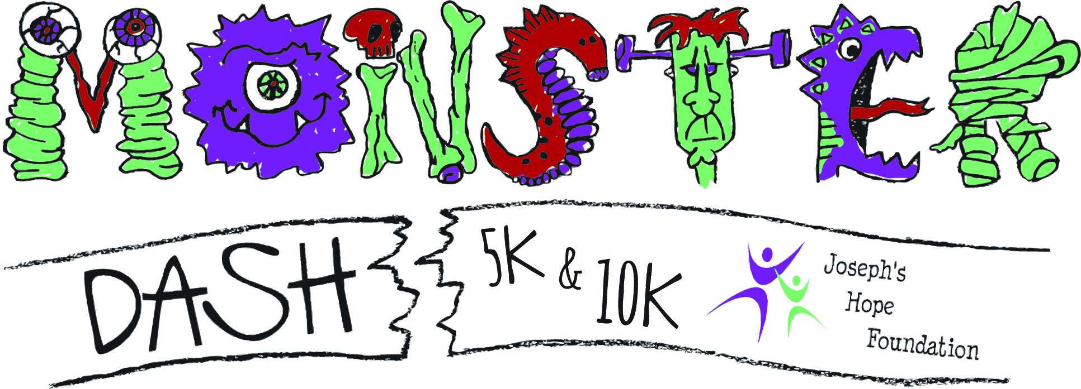
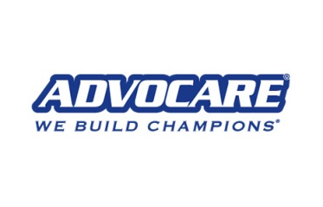
SATURDAY, OCTOBER 24, 2015 – 7PM

NCM Motorsports Park, Bowling Green, KY

10K Run - $35
- Monster Dash Tech T-Shirt for each race participant
- Finishers will receive an amazing medal (while they last)
- All registered participants that complete the course will be automatically registered to win one of several great door prizes

5K Run/Walk - $25
- Everything else noted in the 10K information above (just ½ the distance)

Monster Crawl – Kid’s Obstacle Race - $10
- Registration for one child in the Obstacle Race (which will begin at 6:00PM)
- Finishers of this race will receive a finisher medal (while they last)
- Kids will be entered into a door prize drawing for some amazing prizes.

Trick, Treat and Walk a Mile - $5

Registration Information
1) online anytime at: www.joeshope.org
2) mail-in form below (received by 10/20/2015)
3) Registration at Packet Pick-Up (10/23/15) and limited on-site day of race (this will close at 6PM).

OFFICIAL REGISTRATION FORM

Last Name: ___________________________________________________

First Name: ___________________________________________________

Address: _____________________________________________________

City, State, Zip: ________________________________________________

Email: _______________________________________________________

Phone: _( )________________________________________________

Male ( ) Female ( )

Age on Race Day_________

10K ( ) 5K Run/Walk ( ) Monster Crawl Obstacle Race ( ) 1-Mile Trick-or-Treat Walk ( )

Shirt Unisex S ( ) M ( ) L ( ) XL ( ) 2XL ( )
Women’s S ( ) M ( ) L ( )
Youth S ( ) M ( ) L ( )

PARTICIPATION WAIVER (please read carefully)

In consideration of your acceptance of this entry, I hereby, for myself, my
heirs, executors, and administrators, and anyone entitled to act on
my behalf, release and discharge sponsors, their representatives and
successors, managers, directors, officials, agents, employees and volunteers
of Joseph’s Hope Foundation and the Monster Dash events from all claims of injury or liabilities of any kind, illness or damages suffered by me, as result of my participation in or traveling to and from this event. I attest that I am in proper physical condition to participate in this event.

_____________________________________
SIGNATURE REQUIRED (guardian if under 18)

MAIL ENTRY AND CHECK (payable to Joseph’s Hope Foundation) TO:
Joseph’s Hope Foundation
c/o Benjie Harmon
183 Stephanie Street
Bowling Green, KY 42104

Questions? Email benjie.harmon@wku.edu

